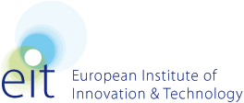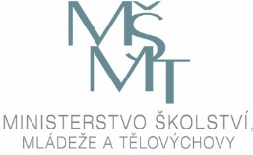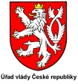

EIT AWARENESS DAY

Tuesday, 22 January 2013

Lichtenstein Palace, U Sovových mlýnů 506/4, 118 00 Praha

PROGRAMME

Moderator Dalibor Štys, MEYS
10:00 Registration and Coffee

10:30 Welcome and Introduction
Rudolf Haňka, Chief Scientific Adviser to Prime Minister
Tomáš Hruda, Vice Minister for Research and Higher Education, MEYS

10:45 Introduction to the EIT and its KICs
Alexander von Gabain, Chairman of the EIT Governing Board

11:15 Experiences and Insights from the first three KICs
Climate-KIC – Manuel Irún Molina
KIC InnoEnergy – Diego Pavía
EIT ICT Labs – Laure Le Bars

12:30 Discussion

13:00 Buffet Lunch and Networking

Moderator Naděžda Witzanyová, MEYS
14:00 Preparing for the next Round of KICs
Alexandre Caldas, Head of Unit KIC Operations

14:30 Discussion

14:45 Possible Catalysts for KIC Formation
Possible activities in 2013 – Damaris Fernandez, Trinity College Dublin
Structural Funds and S3 Strategy – Veronika Czesaná, Gabriela Daniels, MEYS
National programme of sustainability – Dalibor Štys, MEYS

15:30 Discussion

15:45 Closing Session
Jan Marek, Office of the Government

16:00 Close

