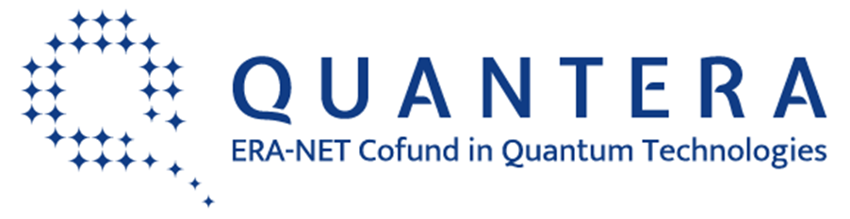
Call 2017 for Transnational Research Proposals
Supporting the topics of
Quantum Information and Communication Sciences and Technologies
Eligibility criteria – Czech Republic

General information

The national funding authority of the Czech Republic responsible for ensuring participation of the Czech entities in the present Call 2017 for Transnational Research Proposals supporting the topics of Quantum Information and Communication Sciences and Technologies launched within the framework of the QUANTERA, ERA-NET Cofund in Quantum Technologies, is the Ministry of Education, Youth and Sports – Department of Research and Development, Unit for European Research Area.

Eligible partners

The participants from the Czech Republic in the projects´ consortia must meet the criteria of the research and knowledge-dissemination organisation (hereinafter referred to as “research organisation”) in accordance with the Framework for State Aid for Research and Development and Innovation (2014/C 198/03). These might be public universities, public research institutes and/or another entities classified as research organisations.

It is obligatory that the Czech participants involved in the projects´ consortia prove compliance with the eligibility criteria and fulfilment of the conditions set by § 18 of the Act No. 130/2002 Coll. on Support of Research, Experimental Development and Innovation from Public Funds and on Amendment to Some Related Acts by means of a Statutory Declaration. The required procedure is described and Statutory Declaration form is available on websites of the Ministry of Education, Youth and Sports: http://www.msmt.cz/vyzkum-a-vyvoj-2/quantera.

Eligible costs

Eligible costs for a Czech participant involved in a project consortium are defined by § 2 of the Act No. 130/2002 Coll. on Support of Research, Experimental Development and Innovation from Public Funds and on Amendment to Some Related Acts. The maximum indirect costs set for the present call are 25 % (flat rate) of direct costs without the sub-contracting.

The aid intensity for activities carried out by a research organisation might be at the level of 100 % provided that the research organisation complies entirely with requirements stipulated by the Article 2.1.1 “Public funding of non-economic activities” of the Framework for State Aid for Research and Development and Innovation (2014/C 198/03) and proves it by means of the above-mentioned Statutory Declaration.

Should the above-stated criteria not be fulfilled by the Czech participant, funding rates will be adjusted appropriately by the Ministry of Education, Youth and Sports and will reach the level of 100 % for fundamental/basic research activities, 50 % for applied research activities and 25 % for experimental development activities.

Each Czech participant in a project consortium is requested to specify the costs related to the envisaged R&D activities in detail by using the Eligible Costs Specification template available on websites of the Ministry of Education, Youth and Sports: http://www.msmt.cz/vyzkum-a-vyvoj-2/quantera.

Eligibility confirmation

All of the requested documentation (i.e. Statutory Declaration and Eligible Costs Specification) shall be sent by each Czech participant in a project consortium to the Ministry of Education, Youth and Sports no later than 15th of March 2017 both by electronic correspondence and post.

The electronic version of requested documentation shall be sent to the address of electronic correspondence monika.kocmanova@msmt.cz.

One signed and stamped hard copy (by the statutory representative of research organisation) of requested documentation shall be submitted as well following the instructions stipulated on websites of the Ministry of Education, Youth and Sports: http://www.msmt.cz/vyzkum-a-vyvoj-2/quantera.

Contact person

Ms. Monika Kocmanova

Ministry of Education, Youth and Sports

Department of Research and Development

Karmelitská 529/5

118 12 Prague 1

Czech Republic

Tel: +420 234 811 467

Email: monika.kocmanova@msmt.cz

www.msmt.cz

