EOSC enters the year 2021 with a new leadership

The EOSC Association entered the year of 2021 with a new leadership, elected at the inaugural General Assembly meeting held on 17th December 2020. The EOSC Association will be chaired by the President and eight Directors to manage and implement the decisions taken by the General Assembly. The EOSC Association was established in mid-2020 under the Belgian national law as an international non-profit organisation. The EOSC Association is gradually taking over the duties and responsibilities of the EOSC Governance operating in previous years. The EOSC Association is also expanding its membership base. The CESNET Association; the Masaryk University, as the host of the CERIT – Scientific Cloud; and the VŠB – Technical University of Ostrava, operating the IT4Innovations National Supercomputing Centre, has already joined the EOSC Association from within the Czech research community. Jointly these three institutions create the Czech national e-infrastructure network e-INFRA CZ. The Ministry of Education, Youth and Sports entrusted the CESNET Association the role of the so-called “Mandated Organisation” to represent the interests of the Czech Republic in the EOSC Association.

e-INFRA CZ – CESNET

The EOSC Initiative
The European Open Science Cloud (EOSC) initiative is a part of the implementation of the European Digital Single Market strategy and the European Open Science policy. The aim of the EOSC is to create a unified data infrastructure in Europe, accessible to both academia and industry, as well as to public service providers. The EOSC is a pan-European initiative based on the principle of making scientific data available according to the FAIR principles, i.e. scientific data are findable, accessible, interoperable and reusable. The EOSC ambition is to offer a virtual environment for more than 1.7 million scientists and 70 million science and technology professionals working in Europe. At the same time, the key principle of the EOSC initiative is that, in addition to the scientist who generates the data during his/her research it can also be used by a scientist who only gains access to it.

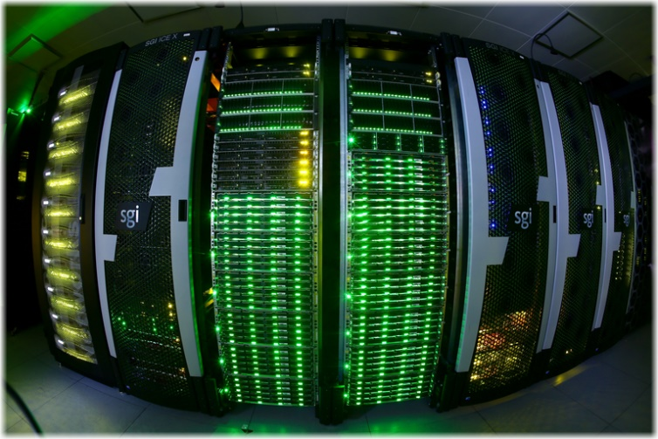
e-INFRA CZ – IT4Innovations National Supercomputing Centre

The EOSC Association
In 2020, the EOSC Association with the statutory seat in Brussels became the legal entity guaranteeing the implementation of the EOSC initiative. The EOSC Association Statutes are available for download at the EOSC websites. During the inaugural meeting of the EOSC General Assembly, which took place on 17th December 2020, Karel Luyben (CESAER) was elected the President of the EOSC Association, jointly with eight Members of the Board of Directors, who are:

- Suzanne Dumouchel (CNRS) – three-year mandate;
- Marialuisa Lavitrano (UNIMIB) – three-year mandate;
- Klaus Tocthermann (ZBW) – three-year mandate;
- Ignacio Blanquer (UPV) – two-year mandate;
- Sarah Jones (GÉANT) – two-year mandate;
- Ronan Byrne (HEAnet) – one-year mandate;
- Bob Jones (CERN) – one-year mandate;
- Wilhelm Widmark (SU) – one-year mandate.

Entities from the EU Member States, Associated Countries and/or Countries Associated with the EU Framework Programme for Research and Innovation may join the EOSC Association as Members.

They may also enter as Observers, as well as institutions from any third country.

The annual membership fee for Members of the EOSC Association is EUR 10.000 and for Observers EUR 2.000.

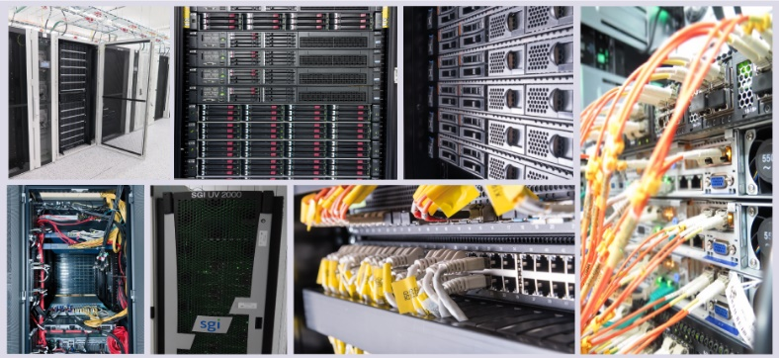
e-INFRA CZ – CERIT Scientific Cloud

The EOSC Association will play a key role in the implementation of the European Partnership to be run under the Horizon Europe EU Framework Programme for Research and Innovation (2021–2027). The mutual interaction between the EOSC Association, being the legal entity bringing together the leading European research stakeholders;

the European Commission, being the implementing body for the 9th EU Framework Programme; and the

EU Member States and Countries Associated to Horizon Europe, will be vital for the successful achievement of the EOSC objectives in the renewed post-2020 European Research Area.

